**Two-pointer Technique - Scenario I**

[Report Issue](https://github.com/LeetCode-Feedback/LeetCode-Feedback/issues)

In the previous chapter, we solve some problems by iterating the array. Typically, we only use one pointer starting from the first element and ending at the last one to do iteration. However, sometimes, we might need to use two pointers at the same time to do the iteration.

*An Example*

Let's start with a classic problem:

Reverse the elements in an array.

The idea is to swap the first element with the end, advance to the next element and swapping repeatedly until it reaches the middle position.

We can use two pointers at the same time to do the iteration: one starts from the first element and another starts from the last element. Continue swapping the elements until the two pointers meet each other.

Here is the code for your reference:

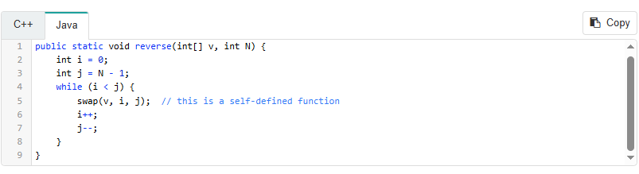

*Summary*

To summarize, one of the typical scenarios to use two-pointer technique is that you want to

Iterate the array from two ends to the middle.

So you can use the two-pointer technique:

One pointer starts from the beginning while the other pointer starts from the end.

And it is worth noting that this technique is often used in a sorted array.